Docker Final Task

Goal of the Exercise
The goal of this exercise is to test your understanding of a Cloud Compute deployment with Terraform.
You are tasked with creating a codebase for a microservice deployment on a cloud environment, using Terraform. Since our focus is not the application itself, the service will be a simple web server that returns a static page.
Requirements
Service Details
The service will be a simple web server that returns a static page.
You can use apache2 or nginx to serve a simple HTML file.
The service should be containerized and stored in a Docker registry.
The service should be deployed on a single VM instance as a docker container.
The image should be pulled from the registry specified earlier.
- The service should not be accessible from the internet but only through a Load Balancer, except for SSH access from specific IP addresses.
Deliverables
You are to provide the following as part of your solution:
- Dockerfile to build the image.
- Terraform codebase to deploy the following:
- Docker registry
- VPC and all required networking resources
- EC2 instance
- Load Balancer
Notes
Since a CI/CD pipeline is not part of this exercise, we will work around that with the help of Terraform.
To push the image to the Docker registry, build the image locally before running the Terraform code.
Once the image registry is created, use Terraform to push the local image to the registry.
Similarly, use Terraform to pull the image from the registry and run it on the VM instance once it is created.
For SSH access:
Use a locally created key.
Add it to the cloud provider key storage.
Attach it to the instance.
Use Terraform best practices for file structure and code organization.
Use variables, locals, modules, etc. when appropriate.
Include all tfvars, scripts, and other helper files used to deploy the application.
You may use any cloud provider of your choosing, although AWS is preferred.
- Use a free tier account or a trial account to deploy the resources.

Title
Terraform-Based Microservice Deployment on AWS using Docker, EC2, and Load Balancer

Objective
The main objective of this exercise is to deploy a simple containerized microservice (static HTML web page) on AWS using Terraform.
The service is hosted inside a Docker container (Nginx) running on a single EC2 instance, and it is exposed only through an Application Load Balancer (ALB).
This deployment ensures:
- The application is not directly accessible from the internet
- Only the Load Balancer can access the application port
- SSH access is allowed only from a specific IP address
- The Docker image is stored in a registry and pulled during deployment

Prerequisites
Before starting this project, the following are required:
- AWS Account (Free Tier preferred)
- Terraform installed on local machine
- AWS CLI configured (aws configure)
- Docker installed and running
- A locally created SSH key pair (example: maruthi.pem)
- Basic understanding of:
  - AWS VPC, Subnets, Security Groups
  - EC2 Instances
  - ALB (Application Load Balancer)
  - Dockerfile and container concepts
  - Terraform variables, tfvars, outputs

Create Docker file
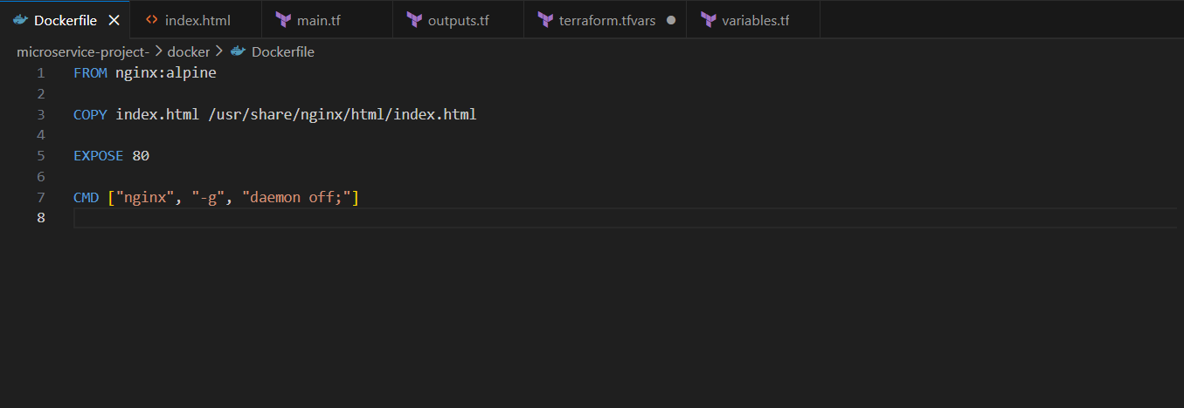

Create Static Web Page
Inside docker/index.html create a simple HTML page:
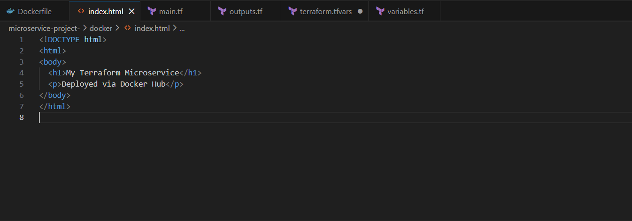

Main.tf
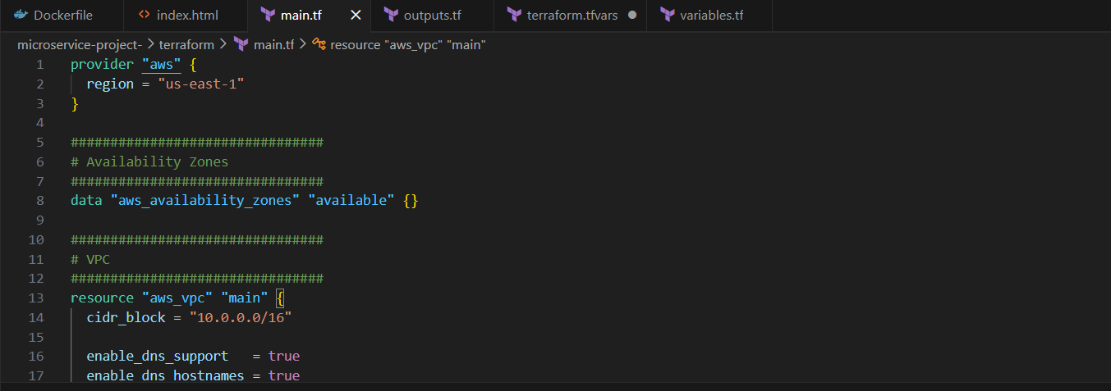

Main.tf File:
provider "aws" {
region = "us-east-1"
}

################################
# Availability Zones
################################
data "aws_availability_zones" "available" {}

################################
# VPC
################################
resource "aws_vpc" "main" {
cidr_block = "10.0.0.0/16"

enable_dns_support = true
enable_dns_hostnames = true
}

################################
# Internet Gateway
################################
resource "aws_internet_gateway" "igw" {
vpc_id = aws_vpc.main.id
}

################################
# Public Subnets
################################
resource "aws_subnet" "public_1" {
vpc_id = aws_vpc.main.id
cidr_block = "10.0.1.0/24"
availability_zone = data.aws_availability_zones.available.names[0]
map_public_ip_on_launch = true
}

resource "aws_subnet" "public_2" {
vpc_id = aws_vpc.main.id
cidr_block = "10.0.2.0/24"
availability_zone = data.aws_availability_zones.available.names[1]
map_public_ip_on_launch = true
}

################################
# Route Table (Public)
################################
resource "aws_route_table" "public" {
vpc_id = aws_vpc.main.id

route {
cidr_block = "0.0.0.0/0"
gateway_id = aws_internet_gateway.igw.id
}
}

resource "aws_route_table_association" "pub1" {
subnet_id = aws_subnet.public_1.id
route_table_id = aws_route_table.public.id
}

resource "aws_route_table_association" "pub2" {
subnet_id = aws_subnet.public_2.id
route_table_id = aws_route_table.public.id
}

################################
# Security Groups
################################
resource "aws_security_group" "alb_sg" {
name = "alb-sg"
vpc_id = aws_vpc.main.id

ingress {
from_port = 80
to_port = 80
protocol = "tcp"
cidr_blocks = ["0.0.0.0/0"]
}

egress {
from_port = 0
to_port = 0
protocol = "-1"
cidr_blocks = ["0.0.0.0/0"]
}
}

resource "aws_security_group" "ec2_sg" {
name = "ec2-sg"
vpc_id = aws_vpc.main.id

ingress {
from_port = 22
to_port = 22
protocol = "tcp"
cidr_blocks = [var.allowed_ssh_ip]
}

ingress {
from_port = 80
to_port = 80
protocol = "tcp"
security_groups = [aws_security_group.alb_sg.id]
}

egress {
from_port = 0
to_port = 0
protocol = "-1"
cidr_blocks = ["0.0.0.0/0"]
}
}

################################
# Load Balancer
################################
resource "aws_lb" "alb" {
name = "micro-alb"
load_balancer_type = "application"

security_groups = [aws_security_group.alb_sg.id]

subnets = [
aws_subnet.public_1.id,
aws_subnet.public_2.id
]
}

resource "aws_lb_target_group" "tg" {
port = 80
protocol = "HTTP"
vpc_id = aws_vpc.main.id

health_check {
path = "/"
}
}

resource "aws_lb_listener" "listener" {
load_balancer_arn = aws_lb.alb.arn
port = 80
protocol = "HTTP"

default_action {
type = "forward"
target_group_arn = aws_lb_target_group.tg.arn
}
}

################################
# AMI (Amazon Linux 2023 x86)
################################
data "aws_ami" "linux" {
most_recent = true
owners = ["amazon"]

filter {
name = "name"
values = ["al2023-ami-*-x86_64"]
}
}

################################
# EC2 Instance (PUBLIC)
################################
resource "aws_instance" "app" {

ami = data.aws_ami.linux.id
instance_type = "t3.micro"

subnet_id = aws_subnet.public_1.id

associate_public_ip_address = true

vpc_security_group_ids = [aws_security_group.ec2_sg.id]

key_name = var.key_name

user_data = <<EOF
#!/bin/bash
exec > /var/log/user-data.log 2>&1

# Install Docker (AL2023 + AL2 safe)
dnf install -y docker || yum install -y docker

systemctl enable docker
systemctl start docker

# Wait for network
sleep 20

docker pull dhanu8688/amazon-nginx:latest

docker rm -f web || true

docker run -d \
--name web \
--restart=always \
-p 80:80 \
dhanu8688/amazon-nginx:latest
EOF
}

################################
# Attach EC2 to Target Group
################################
resource "aws_lb_target_group_attachment" "attach" {
target_group_arn = aws_lb_target_group.tg.arn
target_id = aws_instance.app.id
port = 80
}
Outputs.tf
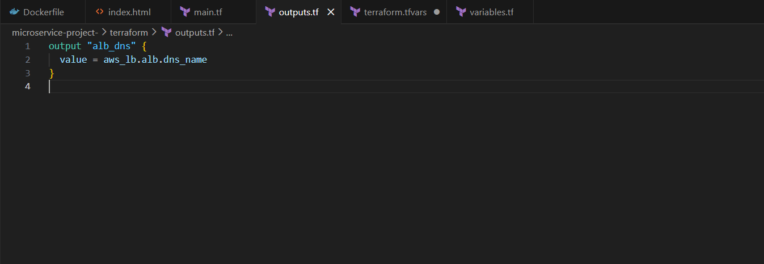
Terraform.tfvars
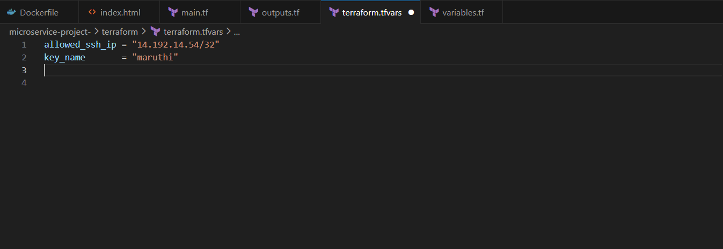
Variables.tf
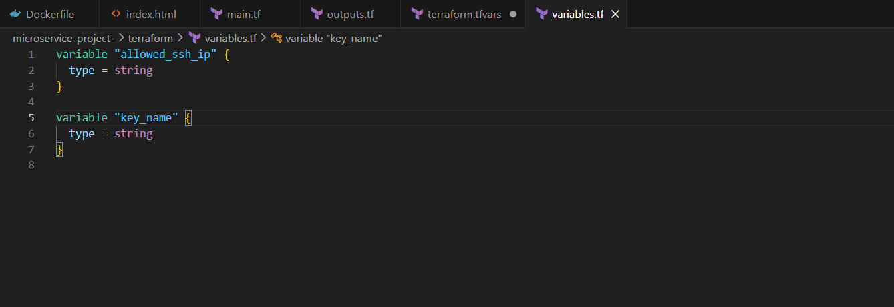

terraform init
terraform plan
terraform apply
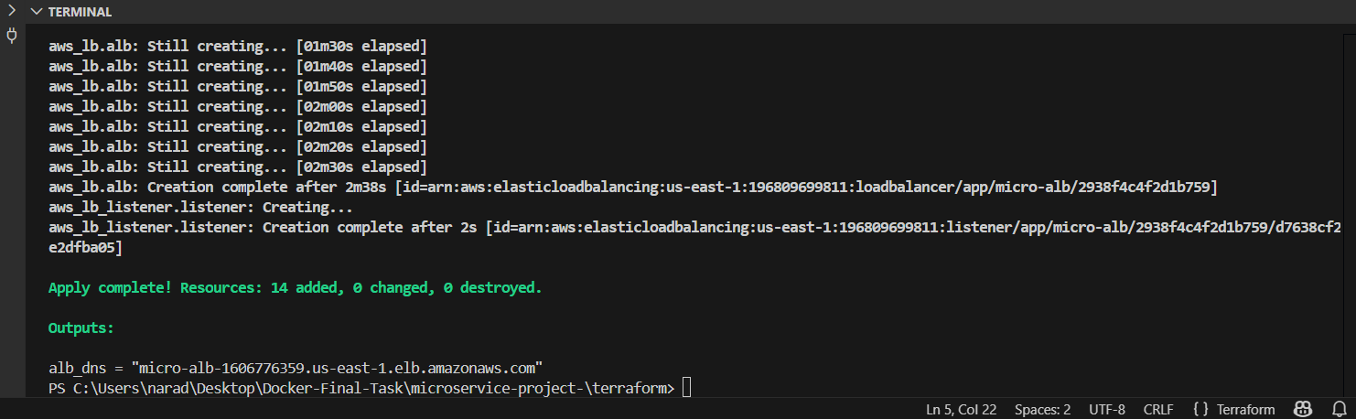

Paste the dns in browser
